Capstone Project

**1.GitHub Repo URL**

[**https://github.com/N-Moorthy/CapstoneProject.git**](https://github.com/N-Moorthy/CapstoneProject.git)

**2.Deployed Site URL**

<http://15.206.93.112:3000/>

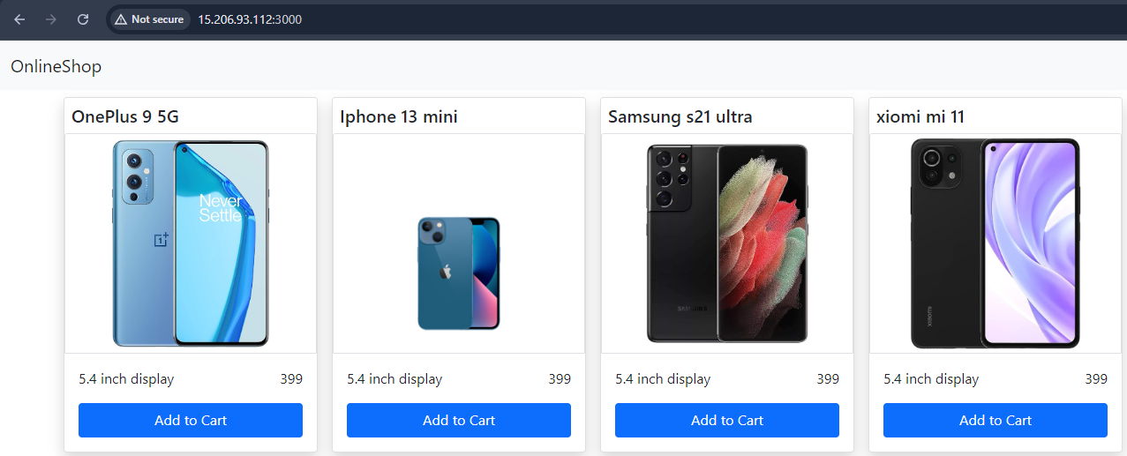

**3. Docker Images with Names**

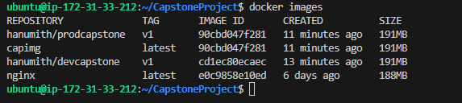

**4. AWS EC2 Console**

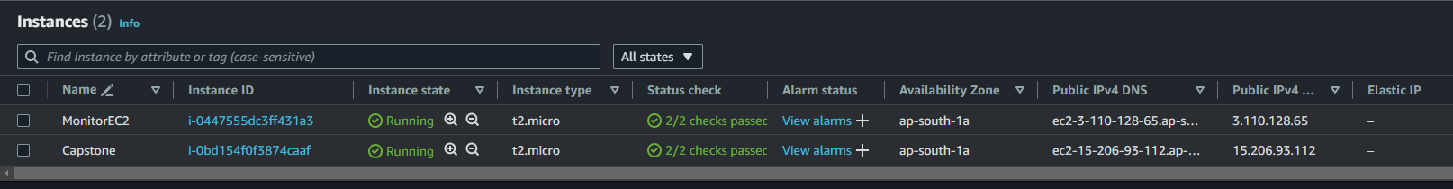

**5. SG Configurations**

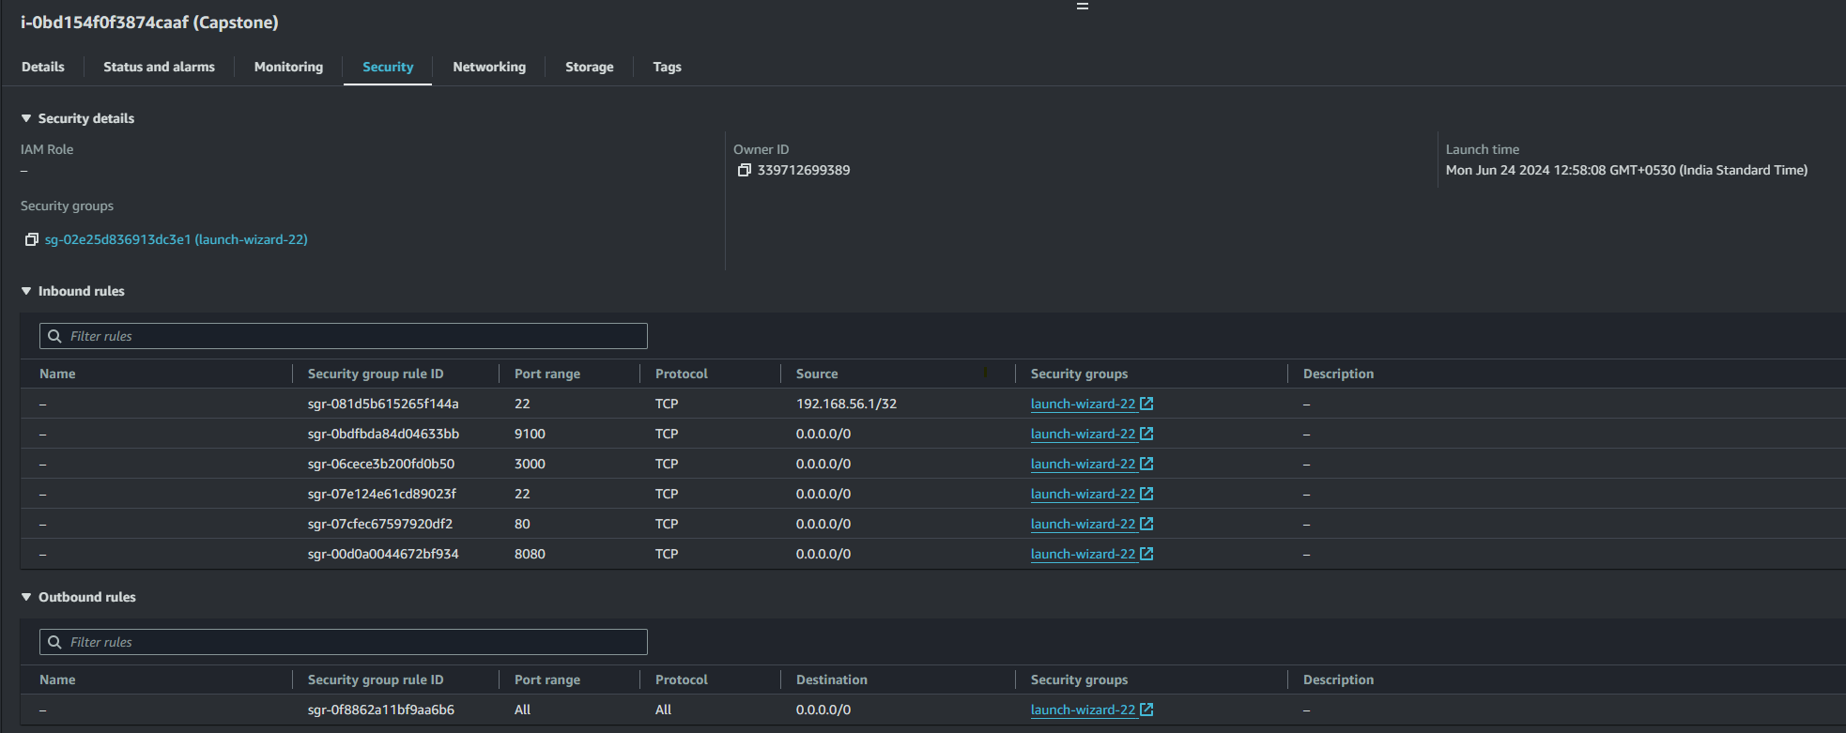

**6.Docker Hub Repos (Private – Prod & Public – Dev) with Image Names**

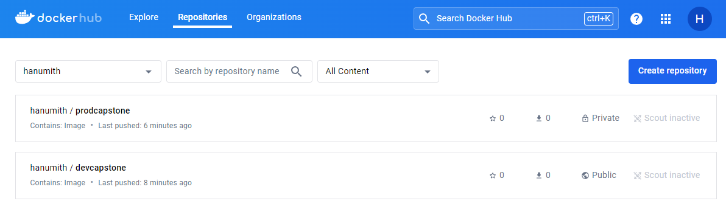

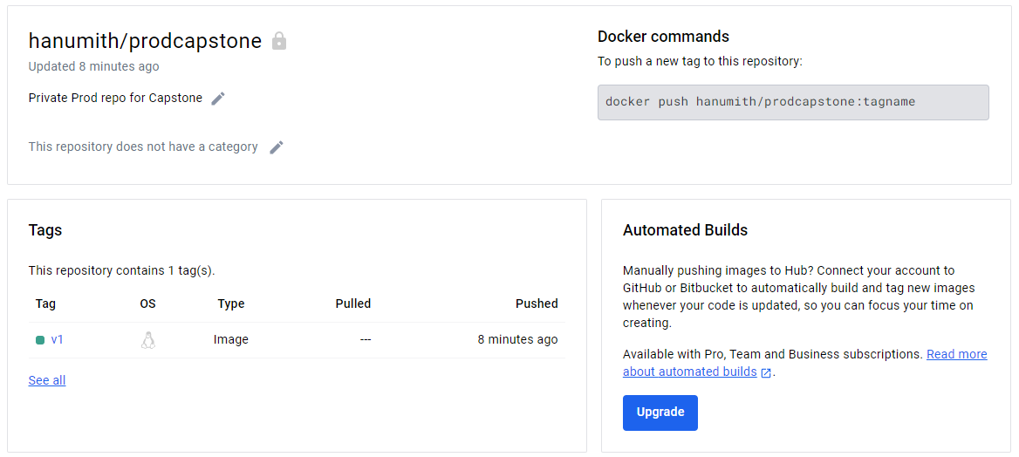

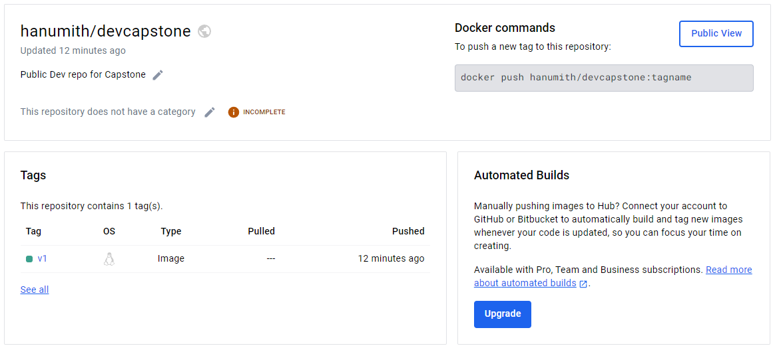

**7.Deployed Site**

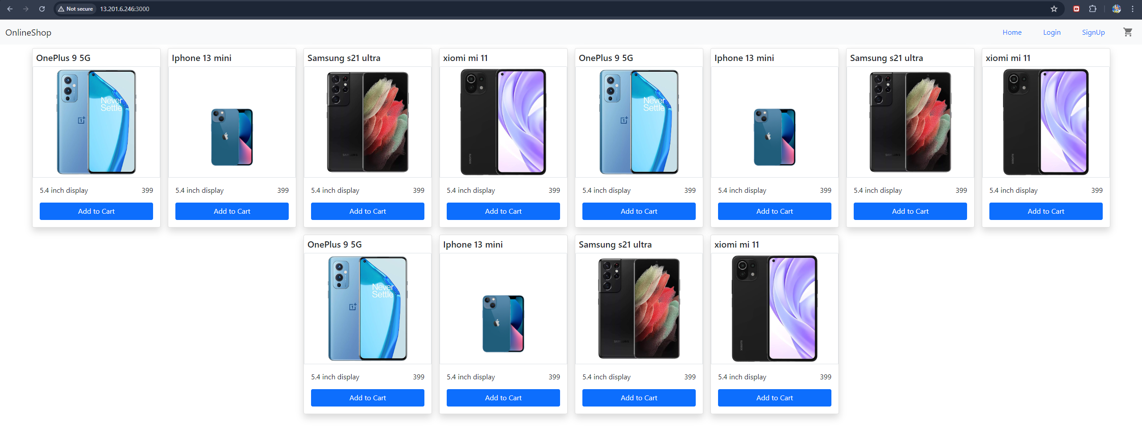

**8.Jenkins Login Screens**

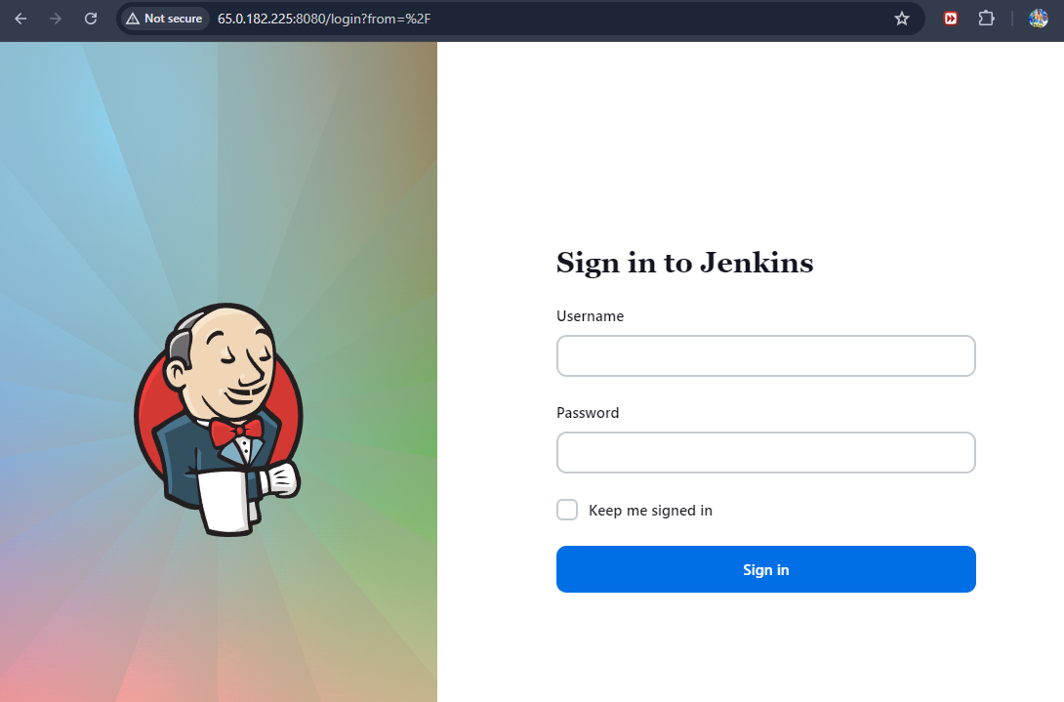

**9. Jenkins Configuration**

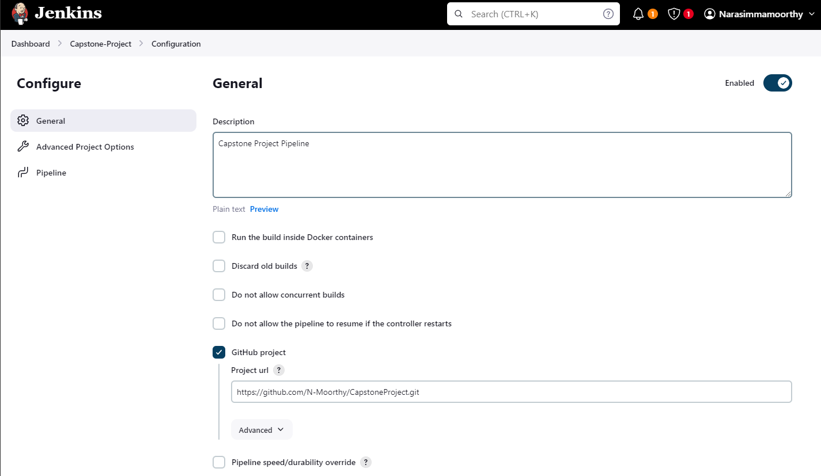

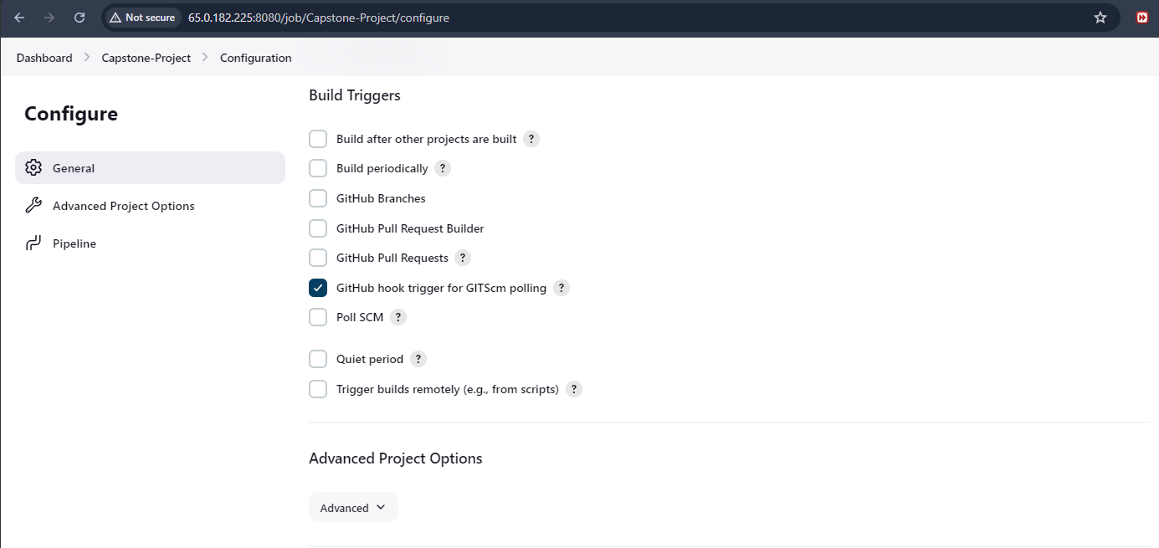

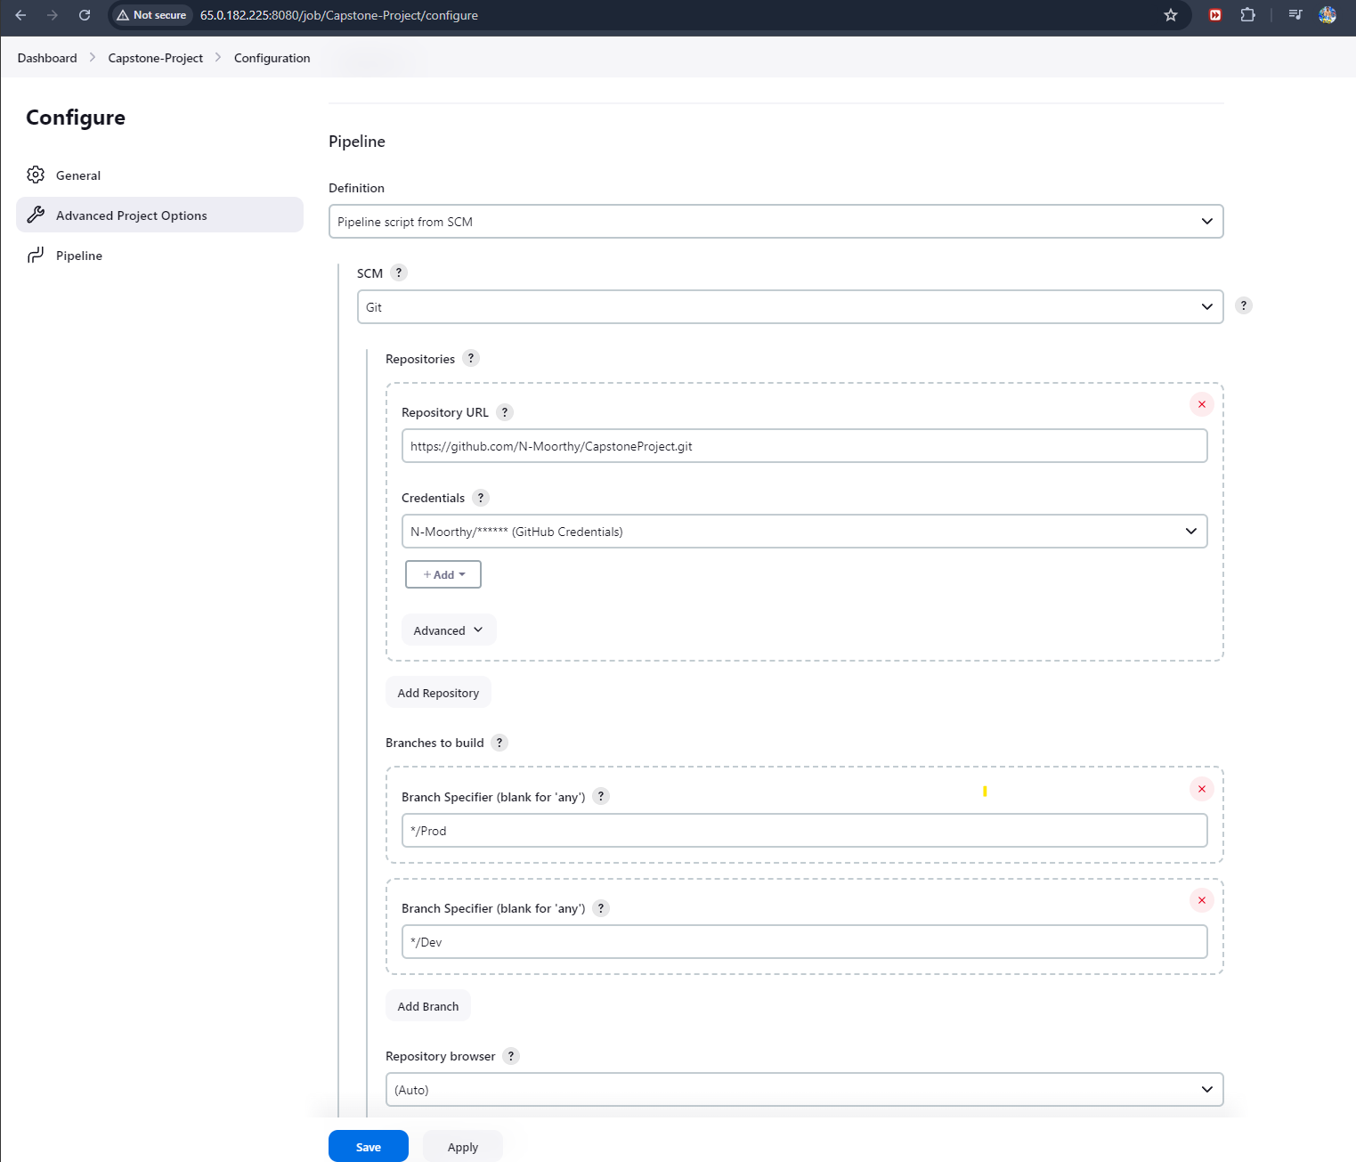

**10. Pipeline Run & Output**

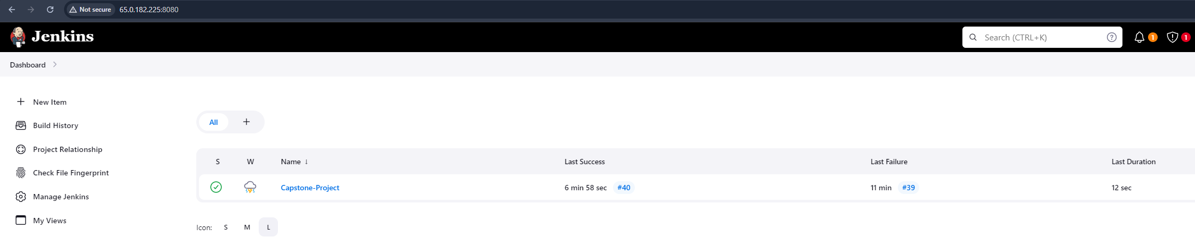

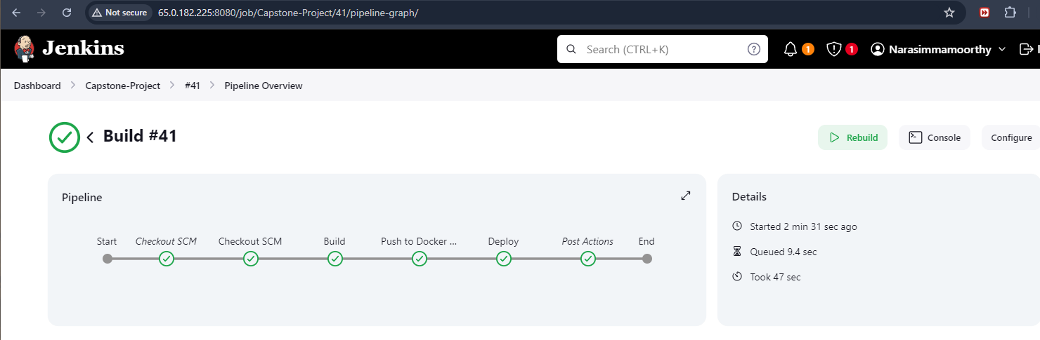

**11.Excuted Steps**

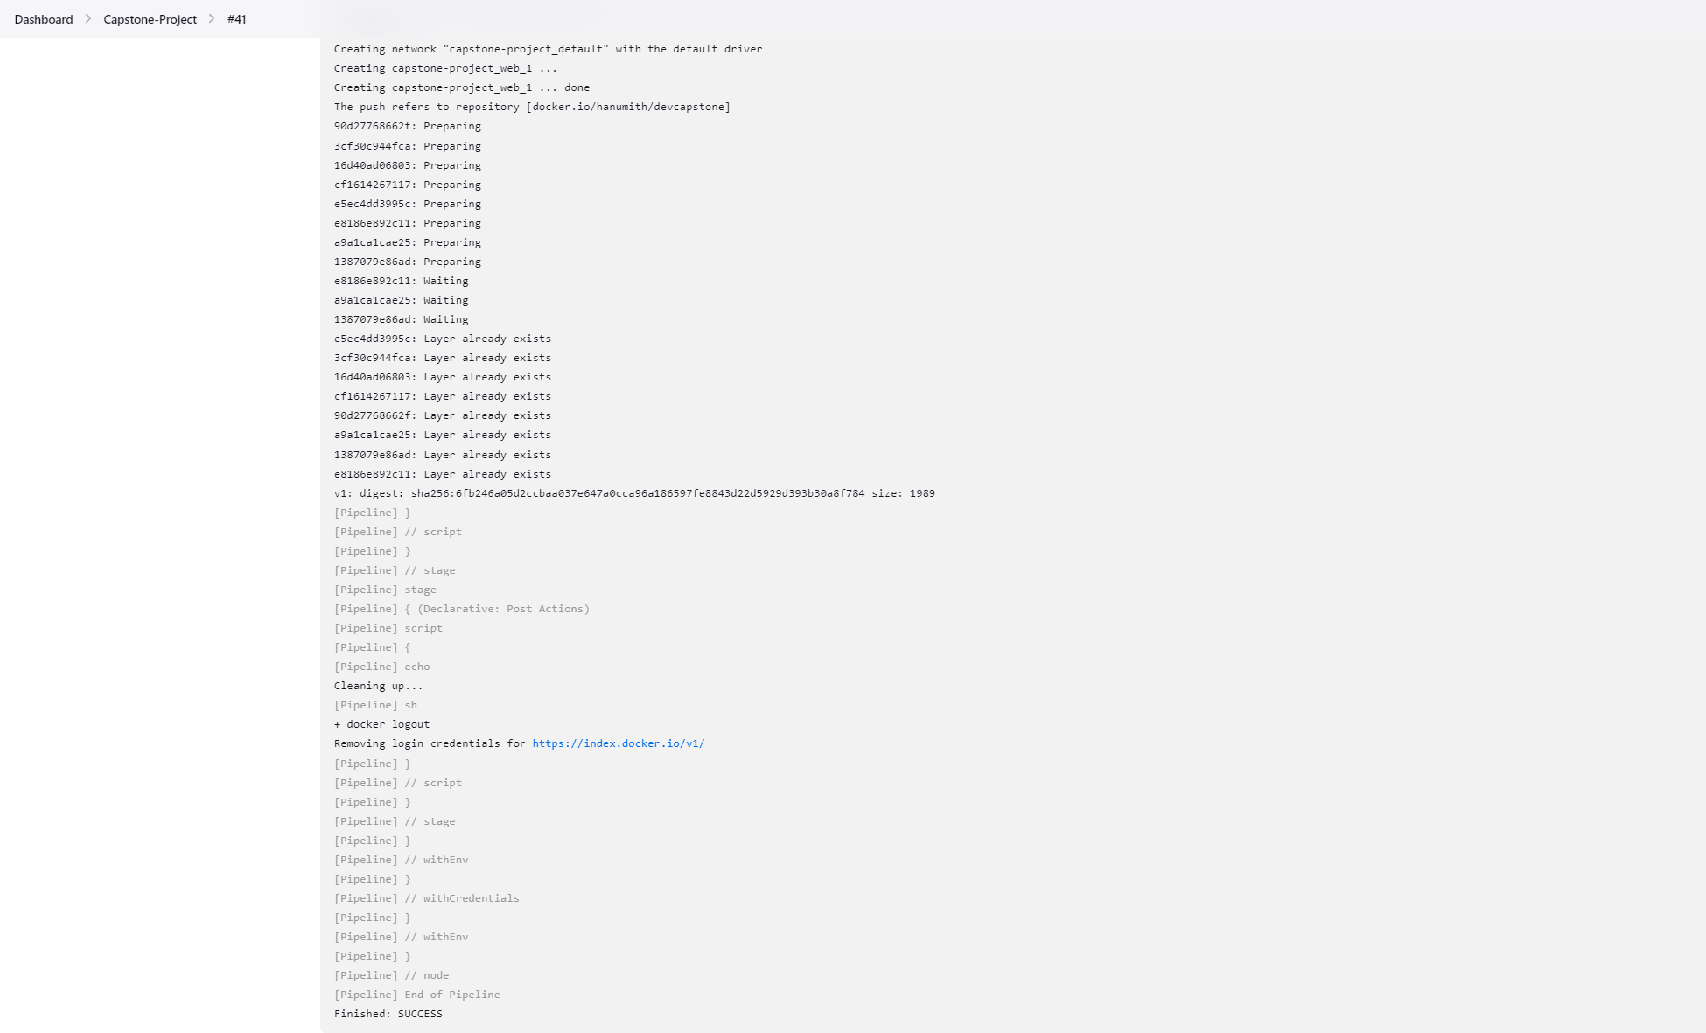

**12. Health Check Monitoring**

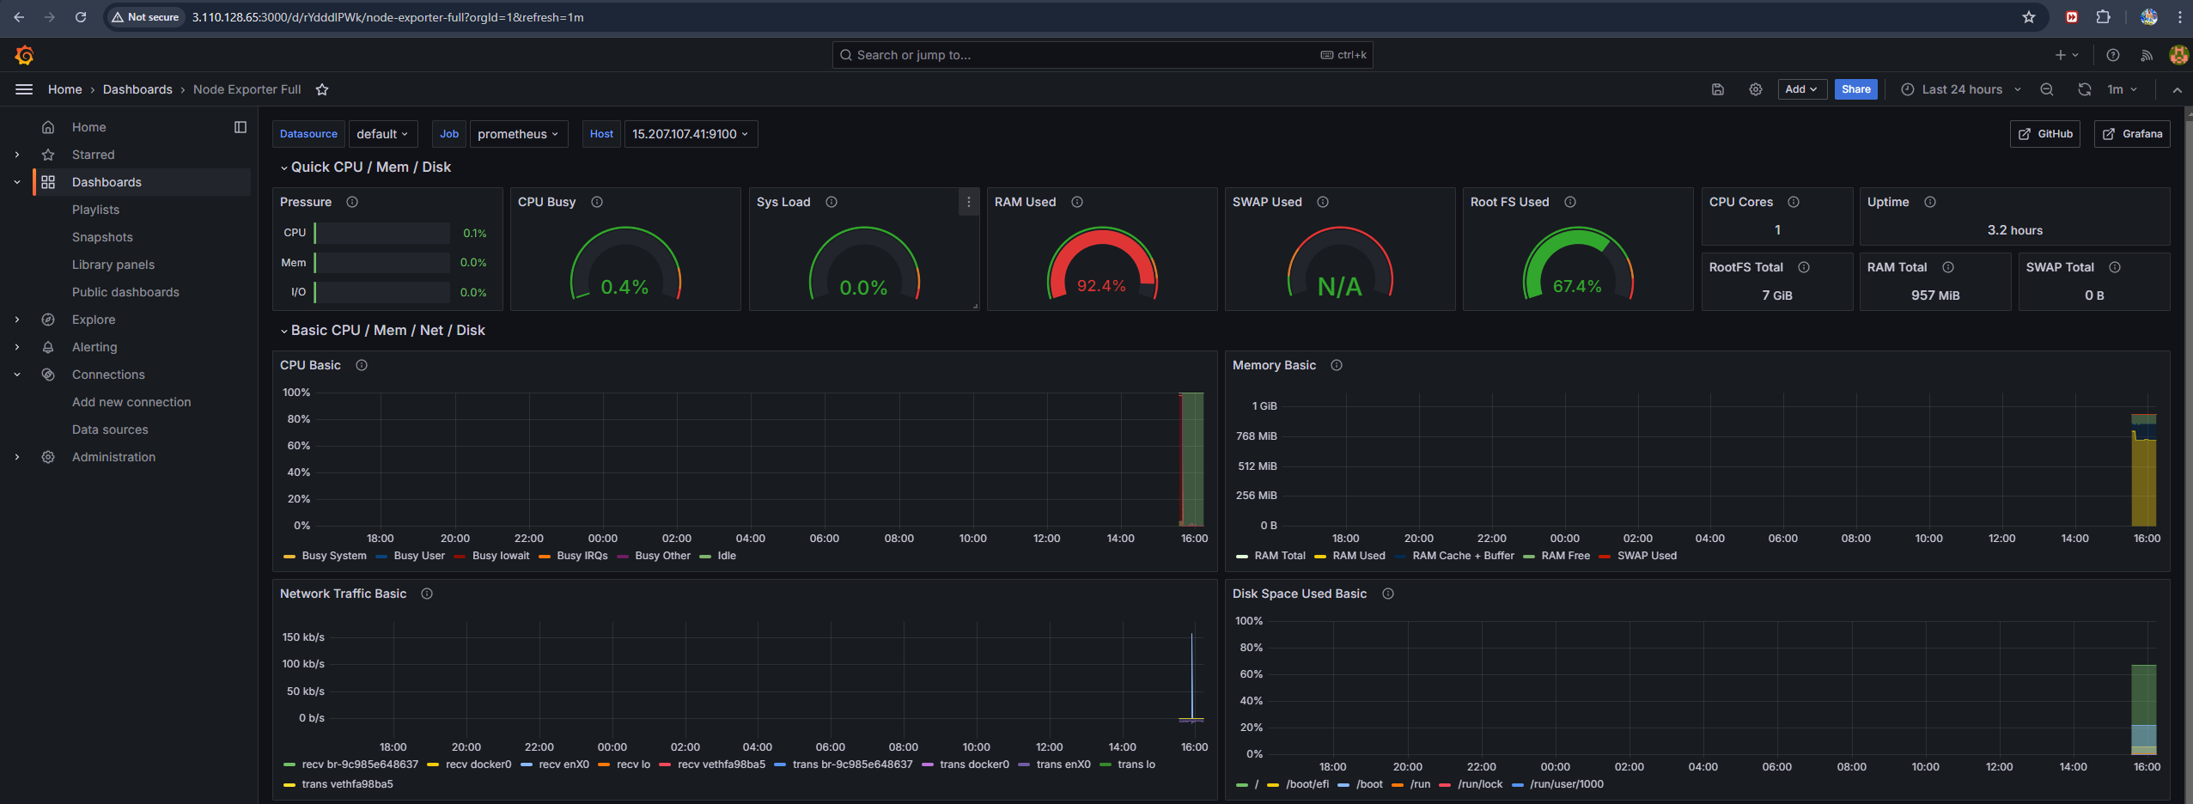

**13. Monitoring Setup with AWS Cloudwatch**

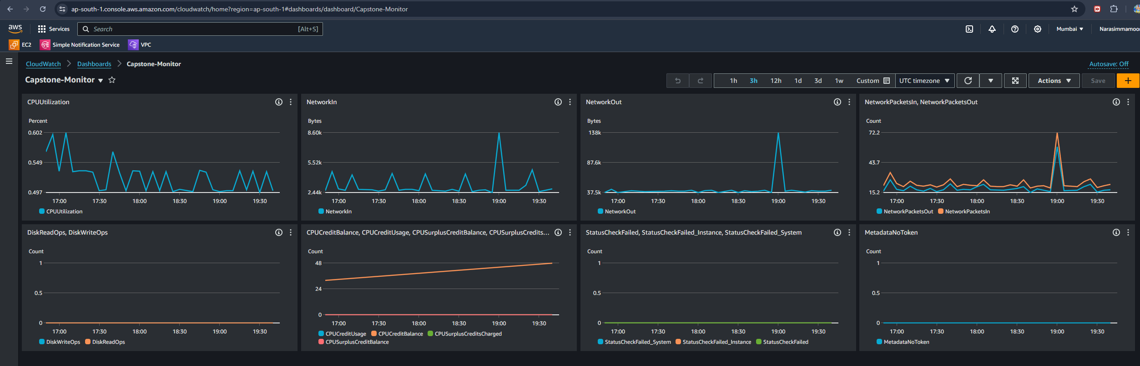

**13.Email alarm notification configuration**

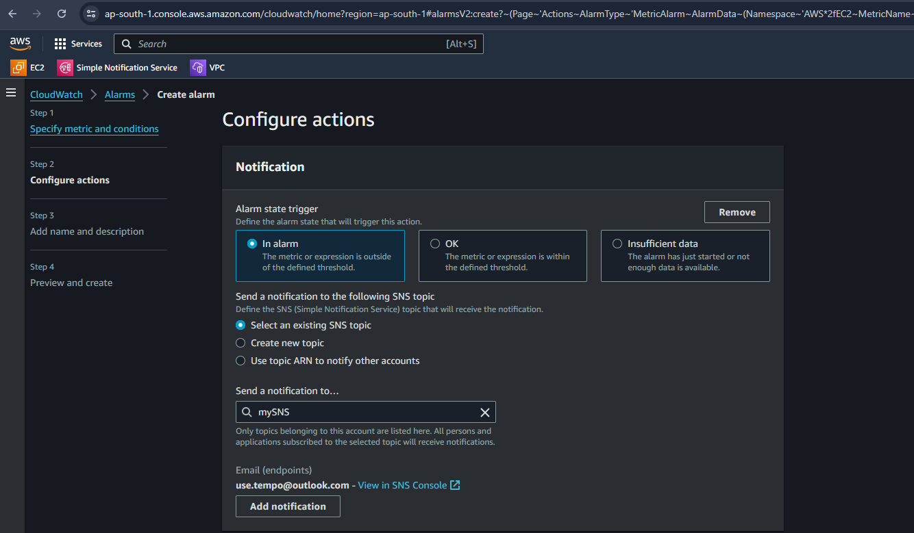

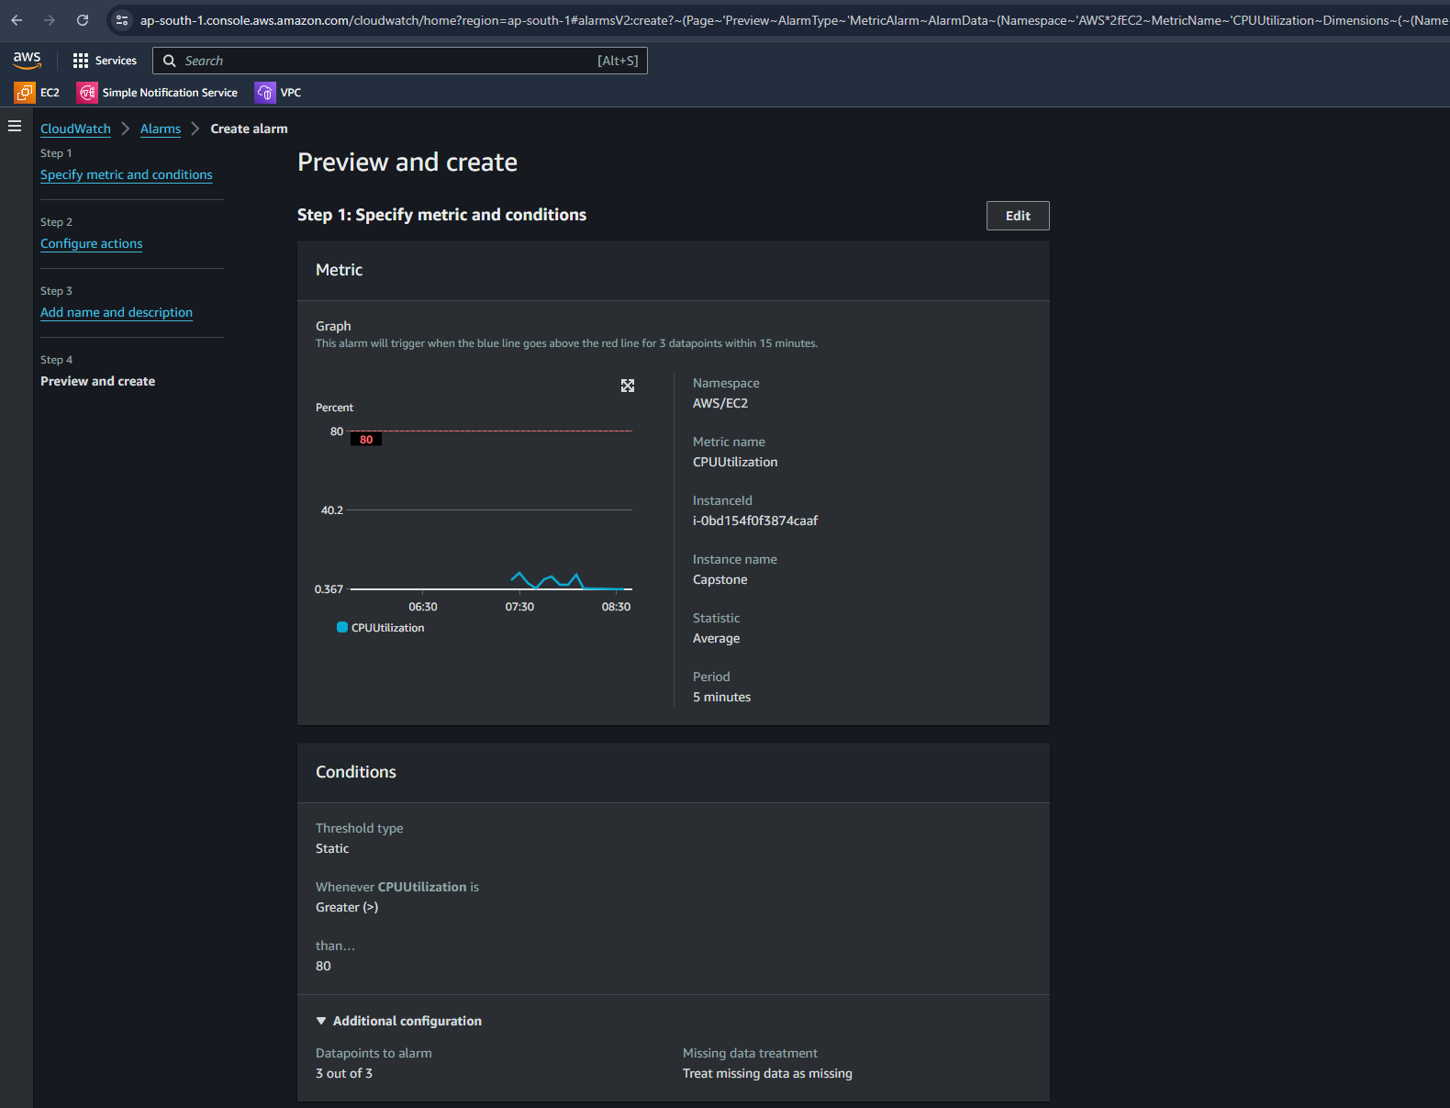

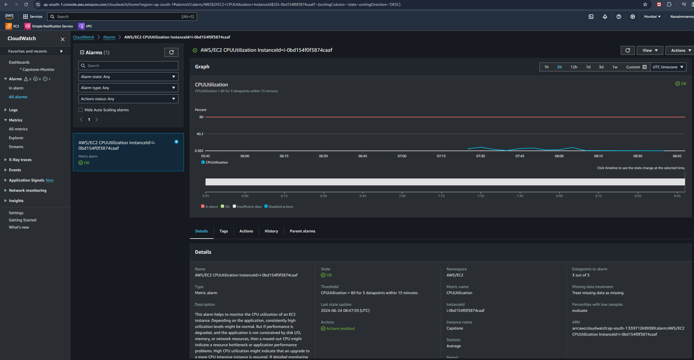

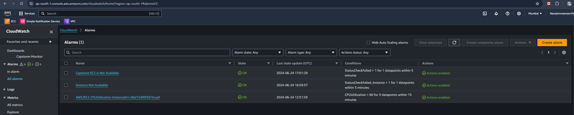

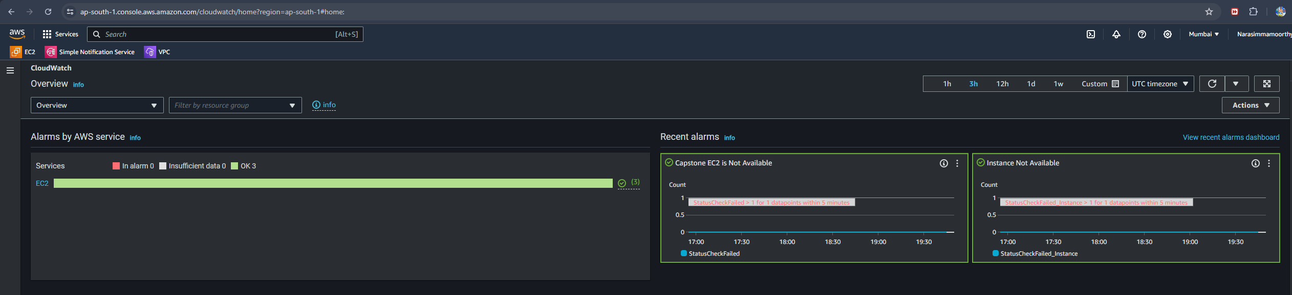

**Narasimmamoorthy**